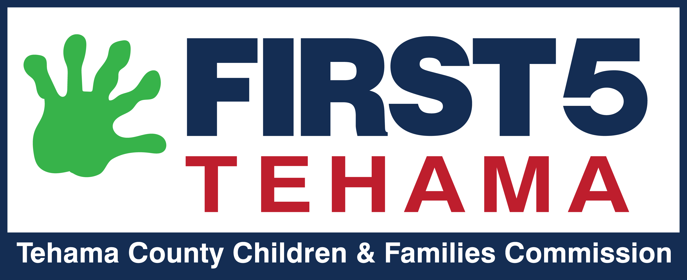

Request for Proposal
Independent Auditor for Fiscal Years Ending

June 30, 2024, 2025, and 2026
Overview:
Tehama County Children and Families Commission (First 5 Tehama) is requesting proposals from qualified firms of Certified Public Accountants to provide comprehensive financial auditing services of First 5 Tehama’s finance statements. The estimated contract period is set to begin July 1, 2024 and conclude June 30, 2026.
Introduction:
First 5 Tehama is seeking an independent auditor, whose primary role will be to conduct the audit of the Commission’s financial statements and an expanded audit as required by the California State Controller’s Office. Additionally, the Auditor would advise Commission staff of new regulations or requirements, and assist in development and refinement of processes. The annual audit is mandated in Section 130140 of the California Health and Safety Code and will include a full review of First 5 Tehama compliance to State statutes governing the Children and Families Trust Fund.
Experienced entities interested in providing these services for First 5 Tehama are encouraged to submit a proposal. The entity selected will have extensive experience with public agencies, auditing experience, demonstrated track record of providing similar services, and must be exceptionally capable of producing the desired services in a highly professional, innovative, timely and cost-conscious manner. An understanding of and/or experience with First 5 Commissions is desirable and preferred.
First 5 Tehama intends to award a contract to an entity that meets its qualification criteria and has successfully performed services on similar projects in the past. The successful Respondent will be able to enter into a contract with the Commission for the services requested in this RFP within a reasonable time after award. The contract period will run from the start date through June 30, 2026. Please note, First 5 Tehama reserves any right to negotiate any proposed activities and/or budgets.
Timeline:
  - February 1, 2024 – Release of Request for Proposals
  - March 15, 2024 – Submission deadline
  - June 2024 – Contract start date

Background
Tehama County Children and Families Commission (a.k.a. First 5 Tehama) was established as the result of the voters of the State of California passing the California Children and Families First Act of 1998 (Proposition 10). This is the initiative that added the additional tax to tobacco products. The Act recognizes the compelling need in California to create and implement a comprehensive, collaborative, and integrated system of information and services to support, and optimize early childhood development beginning at the prenatal stage to five (5) year of age. We administer about $900,000 a year in annual tobacco tax allocations and other leveraged supplemental grants, First 5 Tehama’s funds are held in trust with the Tehama County Treasurer. We have no outside investments. The County of Tehama is the employer of record for the Executive Director staff and is reimbursed for salaries, benefits and a small amount of overhead through those offices. Due to our small size and administrative budget, we do not have an accountant on staff. Financial information I s maintained in-house, by one staff person. We rely on a good working relationship with an auditor to keep us abreast of any new changes and requirements and assist us with processes. First 5 Tehama is not a 501(c)(3) and is not required to file tax statements. Due to the requirements of some funders, we must segregate dollars into separate accounts. Currently, we receive no federal funding.

Scope of Funding and Contract Term:

- Award(s) are contingent on successful negotiation of the contract. The successful bidder shall be required to sign a Commission contract, modified to fit the specific proposal.
- Future requirements may be imposed by the California First 5 Commission during the period of the contract. The Commission will give the contractor a minimum of 30 days’ notice in the event new requirements affect the existing contract, and the parties will negotiate contract modifications. If the Commission and the contractor are unable to agree to required changes, either party may terminate the contract with 30 days’ notice.
- The contractor will be responsible for compliance with all state statutes, and state and county regulations applicable to their operations, whether or not referred to in the agreement with the Commission
- The Contractor will provide expanded audit services specific to First 5 Commissions in accordance with California Health and Safety Code section 130151 for fiscal year 2023-24.
- The audit must be completed for a public hearing at the Commission’s annual meeting no later than October 10, 2024 (exact date TBD)
- The contractor will submit the Financial Statement and Independent Auditors Report to First 5 California and The State Controller’s office by Oct. 31, 2024 following the state’s submission guidelines.
- The contractor will assign a lead contact to First 5 Tehama to carry out the contract activities above.
- The contract period for this procurement cover three fiscal years ending June 30, 2024 through 2026.
- Bidders shall submit a proposal that covers the contract period, although First 5 reserves the right to terminate the contractual relationship based upon performance and availability of funds.
- All bids must be received at First 5 Tehama Commission Office by 4 pm on Thursday, February 29, 2024 (Postmark does not qualify).
- Questions may be submitted in writing to Katie O’Shea, koshea@first5tehama.com

Submission Requirements
Completed proposals must be submitted via email to koshea@first5tehama.com by end of day on Feb 29, 2024. Applicants are responsible for ensuring that submissions are received on time. Late submissions will not be accepted.
Submissions must include the following:
- RFP-Independent Auditor as the email title
- Names, titles, addresses, email addresses, and telephone numbers for at least three (3) references.
- A completed W-9 form
- Description of the firm or business’s qualifications to successfully fulfill the obligations of the contract including your relevant and related experience to providing comprehensive audit services.
- Description of the firm or business’s recommended approach and timeline to providing comprehensive audit services, including the roles of key staff assigned to the project.
- Attach proposed budget in a brief narrative including estimated amounts of time to carry out contract activities. Specifically, detail staff to be assigned to project, respective hourly rates and submit staff resumes. It is assumed that the costs will include the salary and benefits for dedicated staff and related expenses. Costs should be reasonable and well justified.

Award Process:

Each bid will be reviewed to determine its responsiveness to capacity questions and the requirements of the procurement. The Commission reserves the right to withdraw the procurement at any time until the contract is signed, without remedy to the bidders. There is no guarantee that a contract will be awarded after evaluation of all bids.

Commission Decision Schedule and Notice of Funding Recommendation:
The Commission will select a bidder and notify the successful bidder by
Confidentiality:
All bids shall remain confidential until the selection process is completed and a bidder has been notified. Members of the public are allowed to review proposals under public records law, but not until after the award process is completed.

